How To Build a Quinzhee

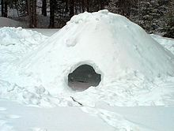

Exterior of a Quinzhee facing the entrance.

A quinzhee or quinzee /ˈkwɪnziː/ is a shelter made by hollowing out a pile of settled snow. This is in contrast to an igloo, which is made from blocks of hard snow. The word is of Athabaskan origin.^{[1][2]}

Uses
For fun or for winter camping and survival purposes, it is possible to construct a Quinzhee, also known as a snow shelter, by gathering a large pile of snow and excavating the inside. The name "Quinzhee" or "Quinzhee" comes from the Athabaskan Indians.

Differences between a Quinzhee and an igloo
The snow for a Quinzhee need not be of the same quality as required for an igloo. Quinzhees are not usually meant as a form of permanent shelter, while igloos can be used for seasonal and year round habitation. The construction of a Quinzhee is much easier than the construction of an igloo, although the overall result is somewhat less sturdy and more prone to collapsing in harsh weather conditions. Quinzhees are normally constructed in times of necessity, usually as an instrument of survival, so aesthetic and long-term dwelling considerations are normally exchanged for economy of time and materials.

Construction
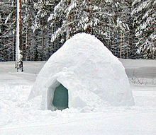

A Quinzhee made in Finland

Quinzhee are typically built on a flat area where snow is in abundance. Builders break up any snowdrifts or naturally formed piles to reduce the risk of collapse due to different amounts of sintering, or powderizing, which can occur. Snow is typically piled 6 to 10 feet high in a circle 8 feet in diameter. It is then left for 2 to 8 hours to sinter, allowing the moisture in the different levels of snow to spread among the crystals and the snow crystals to bond. Quinzhees typically have an inside height after excavation which allows for sitting or crouching but not standing. Many builders insert small sticks of the same length, approximately 10 inches (25 cm), into the top of the structure to be used as a guide when digging out the interior. According to Halfpenny and Ozane, in general the wall at the base should be at least 12 inches wide and at the top about 8 inches thick. A small air vent for circulation can be poked in the roof.

